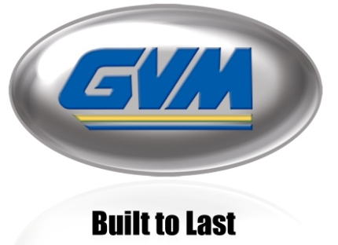
FOR IMMEDIATE RELEASE

GVM Inc. Celebrates 45 years and Announces New T-Series Prowler HVT

Biglerville, PA (USA) – July 09, 2021 – GVM Incorporated celebrates serving the agricultural industry for 45 years and has launched the newly updated 2022 T-Series Prowler. The 2022 Prowler was designed with your bottom line in mind from the start, recognizing that their most valuable resource is their customers.

Beginning in 2022, all Prowlers will be equipped with a Dana HVT R2 transmission with electronic control, bringing improved fuel efficiency, controllability, and reliable performance to the T-Series Prowler platform. Programmable engine rpm and ground speed buttons enable operators to preset spreader and sprayer speeds that can be activated at the touch of a button, improving application consistency. The ergonomic joystick control allows operators to easily vary speed while still maintaining full spinner rates to carry the consistent spread pattern through the start and end of a turn. The 4x4 hydro-mechanical variable speed transmission combines the benefits of a fully mechanical transmission with those of a fully hydrostatic transmission. At low speeds, you get the advantages of a hydrostatic transmission, while at high speeds, you get the efficiency of a fully mechanical transmission. The power has never been better with the new Cummins Stage V engine options and the Dana HVT R2 transmission.

Our customers have reacted positively to the improvements made to the 2022 T-Series Prowlers, expressing their delight. The T-Series Prowler is planned to contend head-to-head with other large floaters, but with the added flexibility of being able to turn from liquid to dry and floater to row crop in less than 30 minutes.

GVM will be displaying and demoing the new Prowlers at multiple regional shows, MAGIE show, GVM’s Ohio, and Pennsylvania Field Days.

GVM will begin production on the T-Series Prowler HVT in late September 2021. For more information, please visit www.gvminc.com .
About GVM Inc.: With 45 years in business, GVM is a well-trusted manufacturer of agricultural application equipment headquartered in Biglerville, Pennsylvania. Their products include the Prowler, Double Duty, Mako, Hydra Spray and the Multi-Grip Tire Handler.

About DANA: Dana is a leader in the design and manufacture of highly efficient propulsion and energy-management solutions for all mobility markets across the globe. The company's conventional and clean-energy solutions support nearly every vehicle manufacturer with drive and motion systems; electrodynamic technologies, including software and controls; and thermal, sealing, and digital solutions. Based in Maumee, Ohio, USA, the company reported sales of $7.1 billion in 2020 with 38,000 associates in 33 countries across six continents. Learn more at dana.com.

Media Contact:
Ashley Light, Marketing Director
800-458-5123 x229
anl@gvminc.com
www.gvminc.com

